**IOT Based Pulse Monitoring System**

**A Project Report**

***In the partial fulfillment for the award of the degree of***

##### **B.Tech**

under

**Ardent Computech Pvt. Ltd.**

###### 

###### ***Submitted by***

**Suprotim Datta**

**Sudhyabrata Guha**

**Subhashis Dutta**

**Akash Chandra Kundu**

**Shubham Kumar**



**Netaji Subhash Engineering College**



**Certificate from the Mentor**

This is to certify that **Suprotim Datta** has successfully completed the project titled **IOT Based Pulse Monitoring System** under my supervision during the period from February to May which is in partial fulfillment of requirements for the award of the B.Tech and submitted to Department **ECE** of **Netaji Subhash Engineering College**

____________________

***Signature of the Mentor***

**Date:**

**Acknowledgement**

I take this opportunity to express my deep gratitude and sincerest thanks to my project mentors, Shouvik Sarkar & Tathagata Chatterjee for giving the most valuable suggestion, helpful guidance and encouragement in the execution of this project work.

I would like to give a special mention to my colleagues. Last but not the least I am grateful to all the faculty members of **Academy of Skill Development** for their support.

**PROJECT OBJECTIVE**

**To design an IOT based Pulse Monitoring System with Cloud Computing.**

**INDEX**

**A. Project Component List**

**B. Description of Each Component**

**C. Project Discussion**

**D. Project Circuit Diagram**

**E. Project Steps**

**F. Result**

**G. Conclusion**

**A. PROJECT COMPONENT LIST**

* + - 1. **NodeMCU ESP8266 WiFi Module**
      2. **Pulse Sensor**
      3. **Jumper Wires**

1. **DESCRIPTION OF EACH COMPONENT**

**1. NodeMCU ESP8266:** NodeMCU is a **low-cost open source IoT platform**. It initially included firmware which runs on the ESP8266 Wi-Fi SoC from Espressif Systems, and hardware which was based on the ESP-12 module. Later, support for the ESP32 32-bit MCU was added.

**2. Pulse Sensor**: Pulse Sensor is a well**-designed plug-and-play heart-rate sensor for Arduino**. It can be used by students, artists, athletes, makers, and game & mobile developers who want to easily incorporate live heart- rate data into their projects.

**3. Jumper Wires:** Jumper wires are simply wires that have connector pins at each end, allowing them to be used **to connect two points to each other without soldering**. Jumper wires are typically used with breadboards and other prototyping tools in order to make it easy to change a circuit as needed.

**C. PROJECT DISCUSSION**

**What is an IOT Based Pulse Monitoring System?**

The Pulse Monitoring system is developed using IOT technology with an objective of detecting the pulse rate of the patient. With the help of IOT application it can be monitored from anywhere in the world.

We have used **THINGSPEAK-** an IOT analytics platform service to monitor the heart rate of the patient.

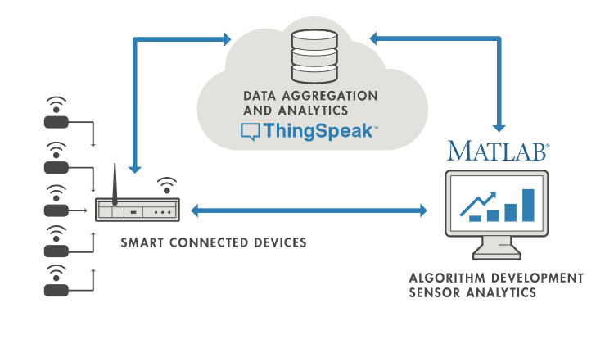

1. **PROJECT CIRCUIT DIAGRAM**

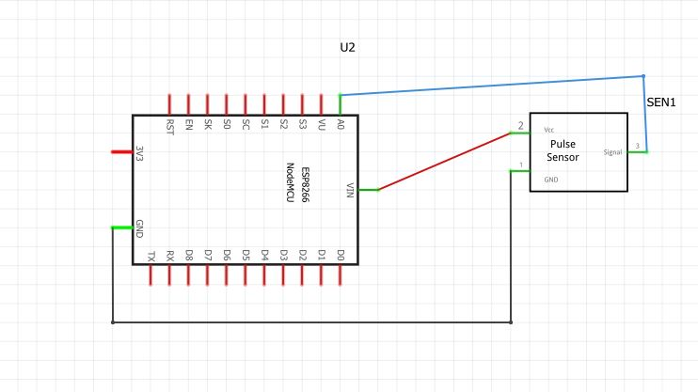

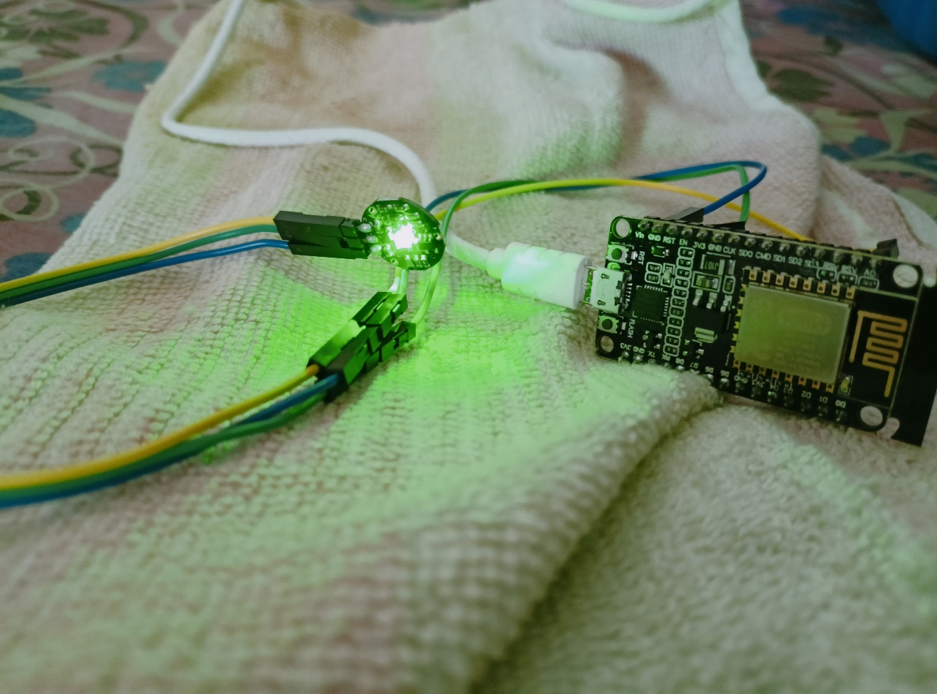

1. **PROJECT STEPS**

**The Circuit**

**The pulse sensor is connected to NodeMCU ESP8266 with the help of jumper wires.**  
**The pins of ESP8266 connected are GND,A0 & Vin.**  
**The circuit is connected to the laptop using a data cable**.

**PLATFORMS USED IN THIS PROJECT**

* Arduino IDE- The open-source Arduino Software (IDE) makes it easy to write code and upload it to the board. This software can be used with any Arduino board.
* Thingspeak - ThingSpeak is an open-source software written in Ruby which allows users to communicate with internet enabled devices. It facilitates data access, retrieval and logging of data by providing an API to both the devices and social network websites.

**ARDUINO CODE**

* In this Arduino ide the ESP8266 & ThingSpeak libraries are used.
* Channel has been created in ThingSpeak & informations like Channel ID & API key have been put in this code which is then uploaded in ESP8266 WiFi module

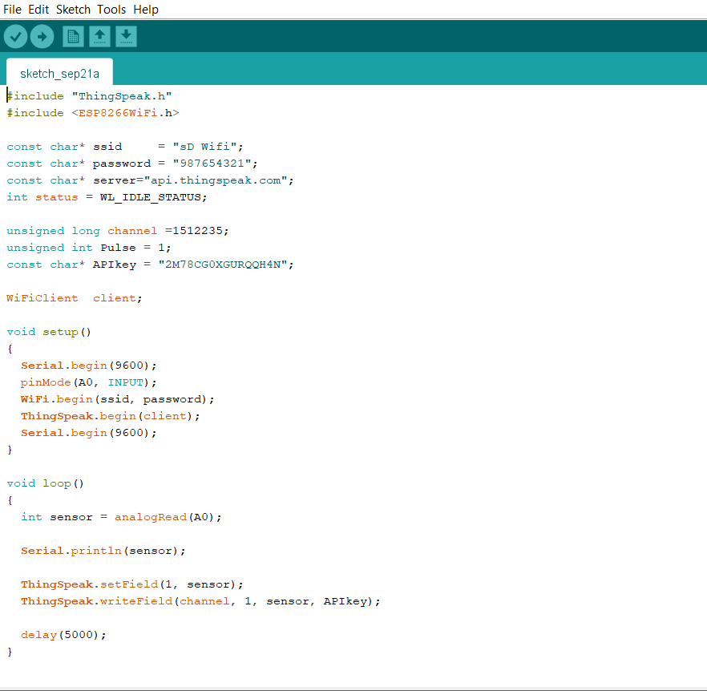

1. **RESULT**

**THINGSPEAK OUTPUT**

* The Channel Stats shows the pulse rate of the patient.
* When the green light emitting from the pulse sensor passes along our skin, the equivalent pulse rate is obtained on the graph at regular interval.

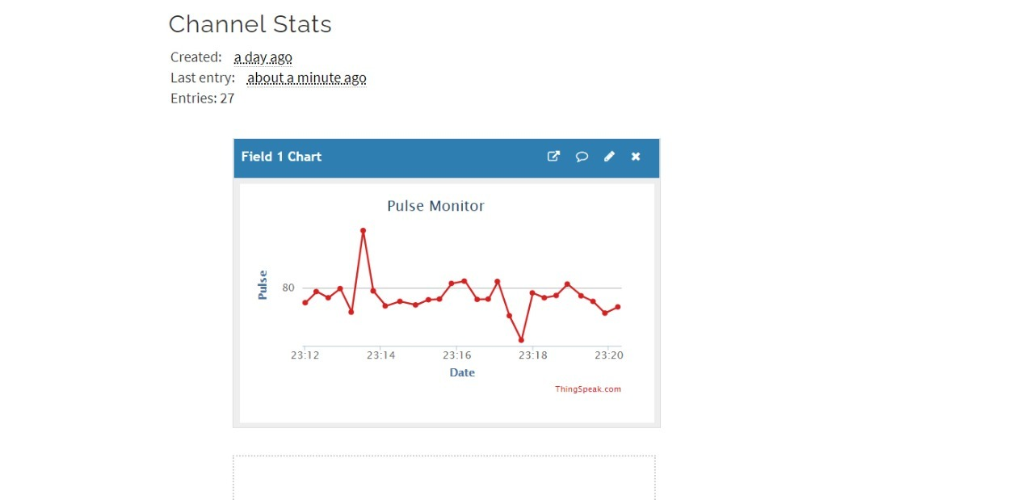

**VIDEO DEMONSTRATION OF THE PROJECT**



**G.CONCLUSION**

IOT based pulse monitoring system is mainly used to determine the pulse rate of patients or exercise intensity of a training session. It is relatively cheap & can be used in many situations.  
  
Since, it is IOT based so it can be monitored from anywhere in the world.

